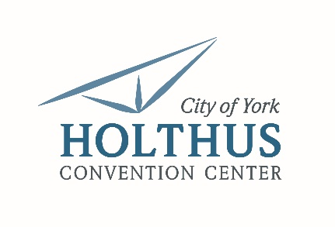

**Holthus Convention Center |** Event Setup Crew

**Summary:** The Convention Center Event Setup Crew is responsible for setup, breakdown and general support for events. He/she must be able to work variable hours, that may include a combination of weekdays, late nights and weekends. Willing to be flexible with school and activity schedules.

**Essential Duties and Responsibilities**

* Provide necessary facility support and services to successfully stage and accommodate events including the physical setup of tables, chairs, linens, staging and additional equipment/supplies as needed.
* Ensure event/room setups and break downs are completed accurately, safely and efficiently according to event plan and seeing diagrams through to completion
* Assist with basic cleaning of facility on an as needed basis. Duties include, but not limited to, trash removal, vacuuming and sweeping/mopping.
* Other duties as assigned

**General Skills**

* Strong organizational and planning skills
* Attention to detail
* Ability to follow written and verbal instructions
* Must be able to work quickly and efficiently in time crunch
* Professional presentation, appearance and work ethic
* Must be able to exert up to 50 lbs. occasionally and/or 25 lbs. frequently

**Required Education/Experience**

* 1 to 3 years of general work experience
* Strong customer/client service skills and a strong work ethic
* Flexible schedule with varying hours between weekdays, evenings and weekends
* Must be willing to work late nights if needed

**For more information or to apply contact:**

Terri Carlson | 402.363.2675 | tcarlson@cityofyork.net